# **SAPka Csapat Kód**

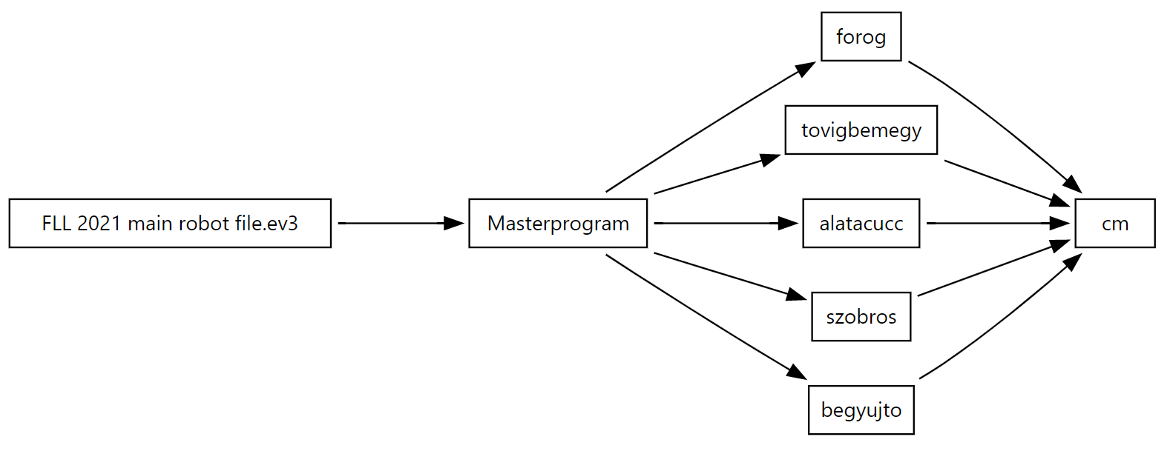

**FLL 2021 main robot file.ev3** CopyrightYear: 2021 | ProjectTitle: main

**└─** [**Masterprogram**](https://ev3treevis.azurewebsites.net/#Masterprogram) #: 16

**├─** [**forog**](https://ev3treevis.azurewebsites.net/#forog) #: 7

**│ └─** [**cm**](https://ev3treevis.azurewebsites.net/#cm) #: 4

**├─** [**tovigbemegy**](https://ev3treevis.azurewebsites.net/#tovigbemegy) #: 9

**│ └─** [**cm**](https://ev3treevis.azurewebsites.net/#cm) #: 4

**├─** [**alatacucc**](https://ev3treevis.azurewebsites.net/#alatacucc) #: 12

**│ └─** [**cm**](https://ev3treevis.azurewebsites.net/#cm) #: 4

**├─** [**szobros**](https://ev3treevis.azurewebsites.net/#szobros) #: 15

**│ └─** [**cm**](https://ev3treevis.azurewebsites.net/#cm) #: 4

**└─** [**begyujto**](https://ev3treevis.azurewebsites.net/#begyujto) #: 4

**└─** [**cm**](https://ev3treevis.azurewebsites.net/#cm) #: 4

**alatacucc**

**├─ StartBlock**

**├─** [**cm**](https://ev3treevis.azurewebsites.net/#cm) cm-in: 88

**├─ Move.Rotations** Ports: B+D | Steering: 45 | Speed: 30 | Rotations: 1 | Brake_At_End: Brake

**├─** [**cm**](https://ev3treevis.azurewebsites.net/#cm) cm-in: 50

**├─ Motor.Degrees** MotorPort: B | Speed: 30 | Degrees: 260 | Brake_At_End: Brake

**├─ Motor.Degrees** MotorPort: D | Speed: -30 | Degrees: 200 | Brake_At_End: Brake

**├─ Move.Degrees** Ports: B+D | Steering: 0 | Speed: 30 | Degrees: 700 | Brake_At_End: Brake

**├─** [**cm**](https://ev3treevis.azurewebsites.net/#cm) cm-in: -20

**├─ Motor.Degrees** MotorPort: B | Speed: -30 | Degrees: 180 | Brake_At_End: Brake

**├─** [**cm**](https://ev3treevis.azurewebsites.net/#cm) cm-in: 30

**├─ Motor.Degrees** MotorPort: B | Speed: 30 | Degrees: 200 | Brake_At_End: Brake

**└─ Move.Rotations** Ports: B+D | Steering: 0 | Speed: 100 | Rotations: 8 | Brake_At_End: Brake

**begyujto**

**├─ StartBlock**

**├─** [**cm**](https://ev3treevis.azurewebsites.net/#cm) cm-in: -50

**├─ Motor.Degrees** MotorPort: D | Speed: 30 | Degrees: 160 | Brake_At_End: Brake

**└─** [**cm**](https://ev3treevis.azurewebsites.net/#cm) cm-in: 70

**cm** cm-in: $cm-in

**├─ StartBlock**

**├─ Math.Advanced** X: 3.14159 | Y: 9.85 | C: $cm-in | D: 0 | Equation: '360/(a*b)*c' | Result: out $dNw9

**├─ CommentBlock** Comment: 'a kör kerületének kiszámítása a kerék megadott méreteivel'

**└─ Move.Degrees** Ports: B+D | Steering: 0 | Speed: 30 | Degrees: $dNw9 | Brake_At_End: Brake

**forog**

**├─ StartBlock**

**├─** [**cm**](https://ev3treevis.azurewebsites.net/#cm) cm-in: 160

**├─ WaitFor(Wait.Timer** How_Long: 1**)**

**├─ Move.Rotations** Ports: B+D | Steering: 0 | Speed: 30 | Rotations: 0.7 | Brake_At_End: Brake

**├─ Motor.Rotations** MotorPort: B | Speed: 60 | Rotations: 5 | Brake_At_End: Brake

**├─** [**cm**](https://ev3treevis.azurewebsites.net/#cm) cm-in: -10

**└─ Move.Rotations** Ports: B+D | Steering: 0 | Speed: -75 | Rotations: 11 | Brake_At_End: Brake

**Masterprogram**

**├─ StartBlock**

**└─ Loop(LoopCondition.Unlimited)** InterruptName: '01'

**└─ Switch(BrickButton.Measure)**

**├─ Case** Pattern: Left

**│ ├─** [**forog**](https://ev3treevis.azurewebsites.net/#forog)

**│ └─ CommentBlock** Comment: 'Futópad feladat'

**├─ Case** Pattern: Center

**│ ├─** [**tovigbemegy**](https://ev3treevis.azurewebsites.net/#tovigbemegy)

**│ └─ CommentBlock** Comment: 'Lépésszámláló'

**├─ Case** Pattern: Right

**│ ├─** [**alatacucc**](https://ev3treevis.azurewebsites.net/#alatacucc)

**│ └─ CommentBlock** Comment: 'Húzockodó'

**├─ Case** Pattern: Down

**│ ├─** [**szobros**](https://ev3treevis.azurewebsites.net/#szobros)

**│ └─ CommentBlock** Comment: 'utolsó feladat, innovációs projekt betolása, pad, táncolás'

**├─ Case** Pattern: None

**│ └─ CommentBlock** Comment: 'alap beállítás'

**└─ Case** Pattern: Up

**├─** [**begyujto**](https://ev3treevis.azurewebsites.net/#begyujto)

**└─ CommentBlock** Comment: 'a lelkött embert begzűjti a robot, ha yavaró helzen van'

**szobros**

**├─ StartBlock**

**├─** [**cm**](https://ev3treevis.azurewebsites.net/#cm) cm-in: 85

**├─** [**cm**](https://ev3treevis.azurewebsites.net/#cm) cm-in: -25

**├─ Motor.Degrees** MotorPort: D | Speed: -30 | Degrees: 400 | Brake_At_End: Brake

**├─ Move.Rotations** Ports: B+D | Steering: 0 | Speed: 40 | Rotations: 1 | Brake_At_End: Brake

**├─ Move.Rotations** Ports: B+D | Steering: 30 | Speed: 30 | Rotations: 1 | Brake_At_End: Brake

**├─ Move.Rotations** Ports: B+D | Steering: 0 | Speed: 35 | Rotations: 1 | Brake_At_End: Brake

**├─** [**cm**](https://ev3treevis.azurewebsites.net/#cm) cm-in: -20

**├─ Motor.Degrees** MotorPort: B | Speed: -30 | Degrees: 400 | Brake_At_End: Brake

**├─** [**cm**](https://ev3treevis.azurewebsites.net/#cm) cm-in: 60

**└─ Loop(LoopCondition.Unlimited)** InterruptName: '01'

**├─ Motor.Rotations** MotorPort: B | Speed: 35 | Rotations: 0.5 | Brake_At_End: Brake

**└─ Motor.Rotations** MotorPort: B | Speed: -35 | Rotations: 0.5 | Brake_At_End: Brake

**tovigbemegy**

**├─ StartBlock**

**├─** [**cm**](https://ev3treevis.azurewebsites.net/#cm) cm-in: -65

**├─ Move.Rotations** Ports: B+D | Steering: 0 | Speed: -10 | Rotations: 0.75 | Brake_At_End: Brake

**├─ Loop(LoopCondition.Count** Iterations_To_Run: 3**)** InterruptName: '01'

**│ ├─ Move.Rotations** Ports: B+D | Steering: 0 | Speed: 10 | Rotations: 0.1 | Brake_At_End: Brake

**│ └─ Move.Rotations** Ports: B+D | Steering: 0 | Speed: -20 | Rotations: 0.5 | Brake_At_End: Brake

**└─ Move.Rotations** Ports: B+D | Steering: 0 | Speed: 75 | Rotations: 8 | Brake_At_End: Brake

A vizualizációt Faragó Attila [ev3treevis.azurewebsites.net](https://ev3treevis.azurewebsites.net/) eszközével csináltuk